**Install Guide**

Admission system

**Contents**

**List of table** 2

**1.** **Revision** 3

**2.** **Install Guide** 4

2.1. Go to Tomcat Server 4

2.2. Login To Manager App 4

2.3. Deploy Product 5

# **List of table**

# **Revision**

|  |  |  |  |  |
| --- | --- | --- | --- | --- |
| **No** | **Version** | **Update date** | **Author** | **Content** |
| 1 | 1.0 | 1/3/2014 | Khau Thanh Dao | Define document |

Table 1: Revision history

# **Install Guide**

## Go to Tomcat Server

Go to tomcat serve Page

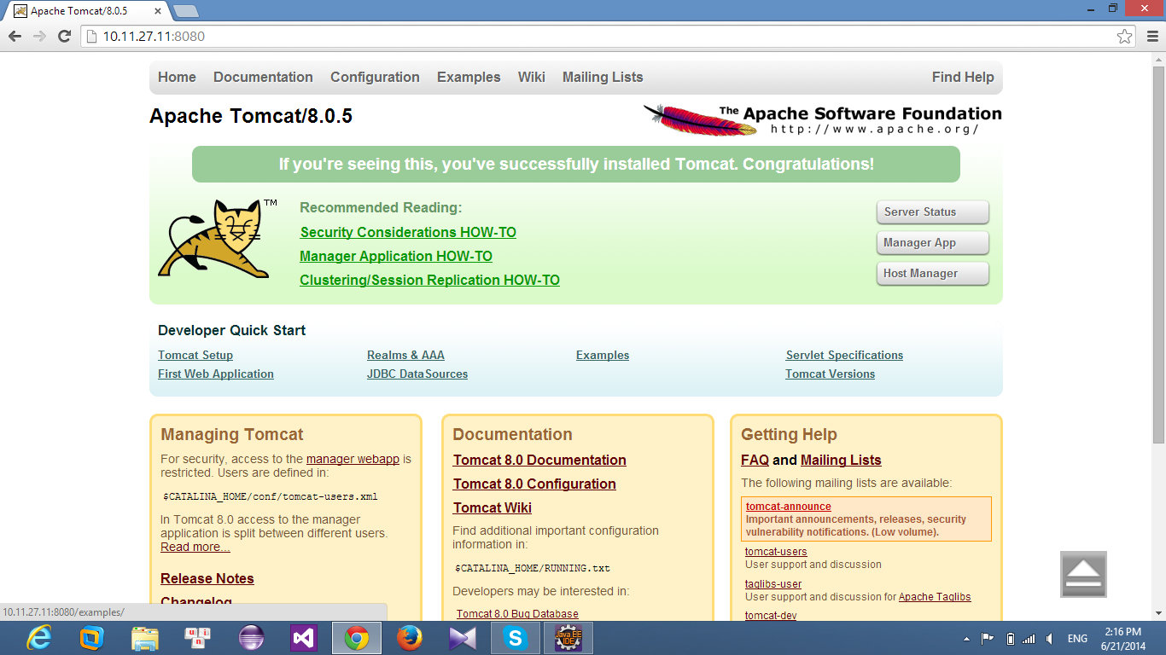

## Login To Manager App

Click Manager App and input Username, Password to go to Application management

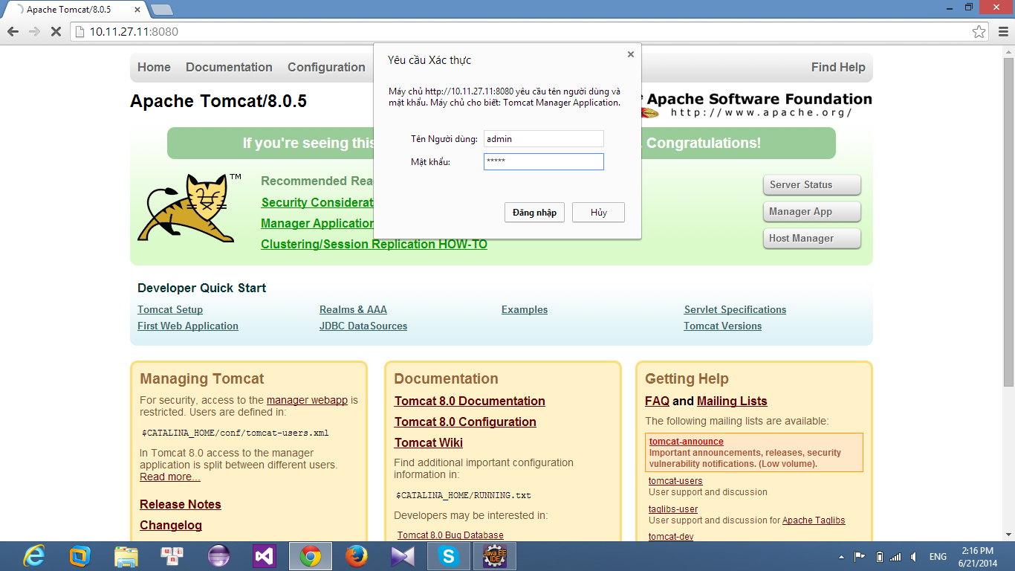

## Deploy Product

Click choose file and choose file need to deploy and click Deloyer.

